# **Setting up the Frozen Lake Environment for Reinforcement Learning (RL)**

Frozen Lake is a nice simple 4x4 grid world environment to setup and begin learning about RL. The action space is very small as well, with the abilities of 0: move left, 1: move down, 2: move right, and 3: move up. The observation or state is the current position of the agent in the gridworld — there are 16 possible states and this info is returned as an integer. Also, the agent always starts in state 0 at the top left of the grid world.

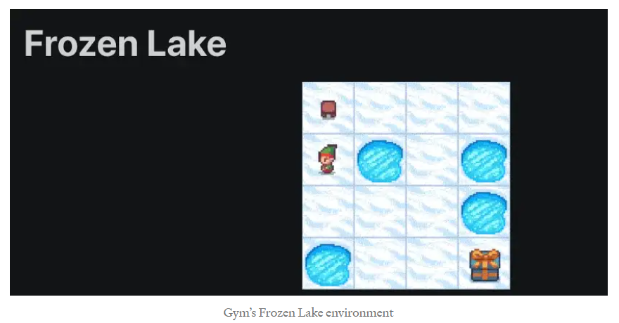

The reward structure is as follows. The agent gets +1 for finding the goal state, +0 for falling into a frozen or hole state. The episode will terminate if an agent falls in a hole, reaches the goal state, or a certain amount of decision steps have elapsed — 100 for the 4x4 grid world. When making the environment some optional key word arguments may be passed to change the 4x4 into an 8x8 grid world using the map_name keyword argument, but I create a 4x4 grid world for demonstration.

Additionally, an is_slippery keyword argument may be passed where is_slippery=TrueIf this parameter is set to true the player will uniformly with 1/3 probability move in the chosen direction, with 1/3 probability move in one of the perpendicular directions, and with 1/3 probability move in the other perpendicular direction. For this article series I will set is_slipery to False to achieve deterministic motion, but a more challenging environment will have it set to True.